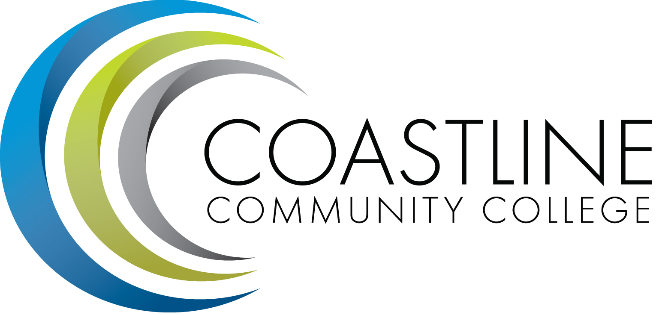
Planning, Institutional Effectiveness, and Accreditation Committee (PIEAC)
December 7, 2016
1:30 p.m. to 3:30 p.m.
Fourth Floor Conference Room

- CALL TO ORDER
  - Roll Call
  - Welcome
  - Adoption of Agenda
  - Approval of Minutes: November 16, 2016

- REPORTS
2.1 Administrative Wing Priorities C. Nguyen
2.2 50% Law C. Nguyen
2.3 2016-17 Planning Report A. Zentner
2.4 2015-16 SAO Findings A. Zentner
2.5 Mission Review Process A. Zentner
2.6 Accreditation Team Development A. Zentner

3. STANDING REPORTS
3.1 Accreditation V. Rodriguez
3.2 Budget Committee R. Lockwood
3.3 Program Review A. Zentner
3.4 Grants D. Aistrich
3.5 President’s Report L. Adrian
3.6 Wing Reports V. Rodriguez, C. Nguyen, R. Miyashiro
3.7 College Council V. Rodriguez
3.8 Facilities C. Nguyen
3.9 MECTBD J. Groot
3.10 Student Success Committee B. Keeler
3.11 Institutional Effectiveness Grant A. Zentner
3.12 College Promise L. Adrian
3.13 Other Committees Committee

4. ANNOUNCEMENTS (1-2 minutes per)

5. ADJOURNMENT

